A Project report on

**Crypto Analyzer**

A Dissertation submitted in partial fulfillment of the academic

requirements for the award of the degree.

**Bachelor of Technology**

**In**

**Computer Science and Engineering (Cyber Security)**

Submitted by

**(Student Name)** **(Roll No)**

B. SUPRAJA 20H51A6215

C. LALITESH SAI 20H51A6219

E.SRI HARSHAVARDHAN REDDY 20H51A6240

Under the esteemed guidance of

**DR. R. VENKATESWARA REDDY**

**HEAD OF DEPARTMENT, CSE (Cyber Security)**



**Department of Computer Science and Engineering (Cyber Security)**

**CMR COLLEGE OF ENGINEERING & TECHNOLOGY**

(An Autonomous Institution, Approved by AICTE, Affiliated to JNTUH, NAAC ’A+’)

KANDLAKOYA, MEDCHAL ROAD, HYDERABAD - 501401.

2020- 2024

### **CMR COLLEGE OF ENGINEERING & TECHNOLOGY**

KANDLAKOYA, MEDCHAL ROAD, HYDERABAD – 501401

DEPARTMENT OF COMPUTER SCIENCE AND ENGINEERING(Cyber Security)



#### **CERTIFICATE**

This is to certify that the Project report on “Crypto Analyzer” being submitted by B. Supraja (20H51A6205), C. Lalitesh Sai (20H51A6209), E. Sri Harshavardhan Reddy (20H51A6210) in partial fulfillment for the award of Bachelor of Technology in Computer Science and Engineering (Cyber Security) is a record of bonafide work carried out his/her under my guidance and supervision. The results embodies in this project report have not been submit any other University or Institute for the award of any Degree.

Dr. R. Venkateswara Reddy

Head Of Department

Dept. of CSE(Cyber Security)

Dr. R. Venkateswara Reddy

Head Of Department

Dept. of CSE(Cyber Security)

##### Acknowledgement

With great pleasure we want to take this opportunity to express my heartfelt gratitude to all the people who helped in making this project work a grand success.

We are grateful to **Dr. R. Venkateswara Reddy,** Dept of Computer Science and Engineering for his valuable suggestions and guidance during the execution of this project work.

We would like to thank **Dr. R.Venkateswara Reddy** Head of the Department of Computer Science and Engineering, for his moral support throughout the period of my study in CMRCET.

We are highly indebted to **Dr.VA Narayana**, Principal CMRCET for giving permission to carry out this project in a successful and fruitful way.

I would like to thank the Teaching & Non- teaching staff of Department of Computer Science and Engineering (Cyber Security) for their co-operation

Finally, I express my sincere thanks to **Mr. Ch. Gopal Reddy, Secretary**, CMR Group of Institutions, for his continuous care. I sincerely acknowledge and thank all those who gave support directly and indirectly in completion of this project work.

­­­­

B. Supraja -20H51A6205

C. Lalitesh Sai -20H51A6209

E. Sri Harshavardhan Reddy -20H51A6210

##### Declaration

We hereby declare that results embodied in this Report of Project on **“ Crypto Analyzer ”** are from work carried out by using partial fulfillment of the requirements for the award of B.Tech degree. We have not submitted this report to any other university / institute for the award of any other degree.

**NAME ROLL NO SIGNATURE**

B. Supraja -20H51A6205

C. Lalitesh Sai -20H51A6209

E. Sri Harshavardhan Reddy -20H51A6210

­­­­

**TABLE OF CONTENTS**

|  |  |  |  |
| --- | --- | --- | --- |
| **CHAPTERS** | | **DESCRIPTION** | **PAGE No** |
|  |  | **ABSTRACT** | 1 |
| **1** |  | **INTRODUCTION** | 2 |
|  | 1.1 | Objective | 4 |
| **2** |  | **SYSTEM ANALYSIS** | 5 |
|  | 2.1 | Literature Review | 6-7 |
| **3** |  | **PROPOSED SYSTEM** | 8 |
|  | 3.1 | Proposed solution | 9 |
|  | 3.2 | Source Code | 10-19 |
|  | 3.3 | System Requirements | 20-23 |
| **4** |  | **DESIGNING** | 24 |
|  | 4.1 | Proposed System Architecture | 25 |
| **5** |  | **RESULTS AND DISCUSSION** | 26 |
|  | 5.1 | Results | 27-30 |
| **6** |  | **CONCLUSION AND FUTURE WORK** | 31 |
|  | 6.1 | Conclusion | 32 |
|  | 6.2 | Future work | 32 |
| **7** |  | **REFERENCES** | 33 |
|  | 7.1 | References | 34 |

**ABSTRACT**

Due to the rapid development of information and communication technologies, many activities in our daily lives have been merged online, and they have become more flexible and more effective. A huge growth in the increasing number of online users has activated virtual word concepts and created a new business phenomenon, which is to facilitate financial activities such as buying, selling, and trading. The growth of cryptocurrencies has been abnormal in recent years, so people are willing to trade in cryptocurrencies. For people to have a detailed analysis of the cryptocurrencies which can help them in trading, we are going to develop a web application which can give them an analysis of each cryptocurrency and provide graphs and an updated price every 24 hours.

1

CHAPTER 1

# INTRODUCTION

2

**CHAPTER 1**

**INTRODUCTION**

A cryptocurrency is a digital currency, which is an alternative form of payment created using encryption algorithms. The use of encryption technologies means that cryptocurrencies function both as a currency and as a virtual accounting system.

Cryptocurrency analysis involves using mathematical indicators to evaluate statistical trends to predict price direction in the crypto market. This is done by looking at past price changes and volume data to determine how the market works and predict how it will affect future price changes. Cryptocurrency analysis methods evaluate crypto markets and identify trading opportunities through price trends and patterns seen on charts. They are based on the belief that a crypto's past trading activity and price changes are valuable indicators in determining future price and activity.

The popularity of virtual or digital currency such as Bitcoins, Litecoins, Ethers, and many more are expected to drive the market in the forthcoming years. People from developed countries are likely to adopt the easy and flexible transactional method offered by digital currency. This popularity of virtual currency as an exchanging medium led the central bank to support digital currency. The central bank patented Central Bank Digital Currency (CBDC) activity provisions for the digital currency projects across many developed countries. For instance, the Bank of Thailand and Central Bank of Uruguay are applying the toolkit to its CBDC evaluation process; the Eastern Caribbean Central Bank and People's Bank of China also support CBDC for adopting digital cash as an exchange medium. Several companies, such as Facebook, Inc., are expanding their business by offering digital money. For instance, in June 2019, Facebook, Inc. launched a digital currency named Libra. Libra will enable customers to buy things or send money to others and cash out Libra online or at grocery shops. Additionally, companies can benefit from fluctuating digital currency prices and strengthen their digital assets.

3

Bitcoin is one of the most popular and majorly adopted digital cash across the world. The rising visibility, growing interest of investors, and supporting regulations are further augmenting the market's growth. Maturing bitcoin cash value and the facility to offer rewards for transactions are also up surging digital cash's market value. Developing countries like Japan, the U.S., European countries, and many more indicate people's inclination towards digital currency, which is expected to facilitate the cryptocurrency market growth in upcoming years.

**1.1 OBJECTIVE**

The main objective on the project of Crypto Analyzer is to develop a simple and user-friendly Web application to know the price of the cryptocurrencies and provide an analysis of each cryptocurrency by providing a detailed graph and an updated value every 24 hours, which helps in finding if the value of the cryptocurrency has increased or decreased compared to the previous day. The user can also log in and bookmark so that they can monitor particular Cryptocurrencies.

Functionalities provided by Crypto Analyzer are as follows:

* Search option will be provided to search for a specific cryptocurrency
* Detailed Graphs of each cryptocurrency is provided
* Graphs contains the details of previous day, last month, 3 months and 1year
* Simple interface and easy to understand for beginners

4

CHAPTER 2

SYSTEM ANALYSIS

5

**CHAPTER 2**

**SYSTEM ANALYSIS**

System Analysis is the important phase in the system development process. The System is studied to the minute details and analyzed. The system analyst plays an important role of an interrogator and dwells deep into the working of the present system. In analysis, a detailed study of these operations performed by the system and their relationships within and outside the system is done. A key question considered here is, “what must be done to solve the problem?” The system is viewed as a whole and the inputs to the system are identified. Once analysis is completed the analyst has a firm understanding of what is to be done.

**2.1 LITERATURE REVIEW**

The adaptation and acceptance level of Cryptocurrency has increased and can be recognized by the following indicators: market capitalization, the estimated number of users, and transaction volume. The cryptocurrency market value reached its peak at the end of 2017 at more than $800B. However the high volatility of the price influence the market capitalization dramatically. Cryptocurrency can be used as an alternative banking system or storage system of wealth especially since it is mostly not tied to a central or government authority. It can be used as a store of value or assets as well as currency. The analysis of the cryptocurrency is needed for those who already are already investing and also for those who want to invest in the near future. the crypto analysis follows on-chain data where You'll get access to precise graphs of on-chain data, including the 24-hour change, the market cap, and more. Data on the blockchain is accessible to everyone. In other words, the information you're receiving is accurate and transparent.

ANALYSIS OF THE CRYPTOCURRENCY ADAPTATION DECISION-Saeed Alzahrani, Tugral Dalm

CRYPTOCURRENCIES IN MODERN FINANCE-Abderahman Rejab, Karim Rejab, John G. Keogh

6

**EXISTING SOLUTIONS:**

LIVE COIN SWITCH:

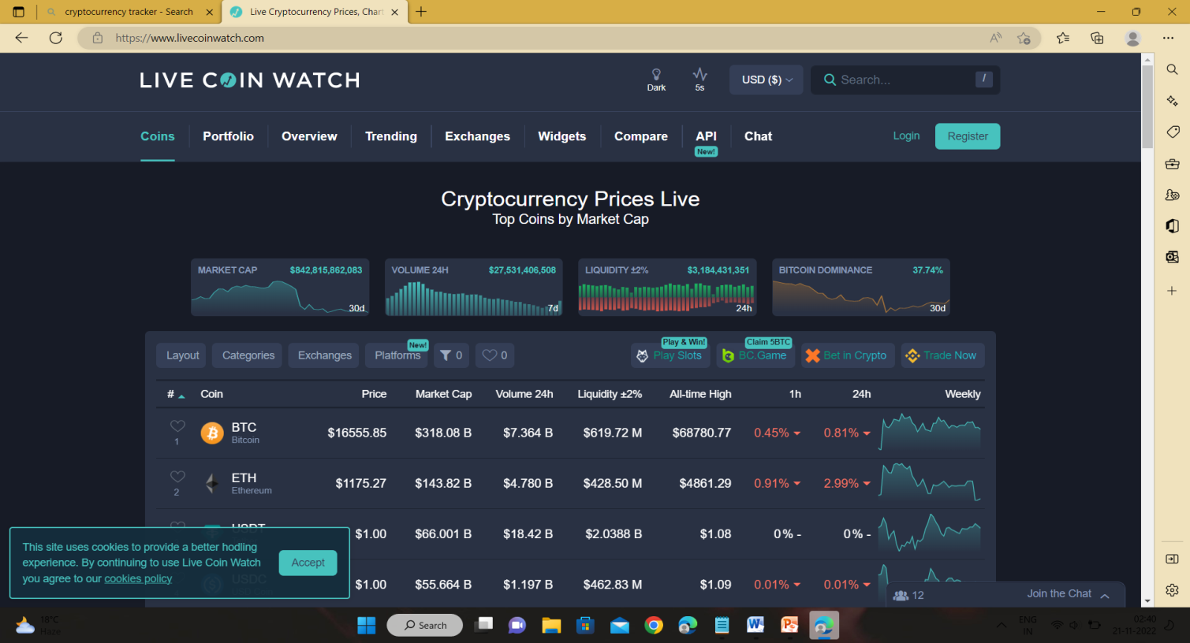

CRYPTOMISO:

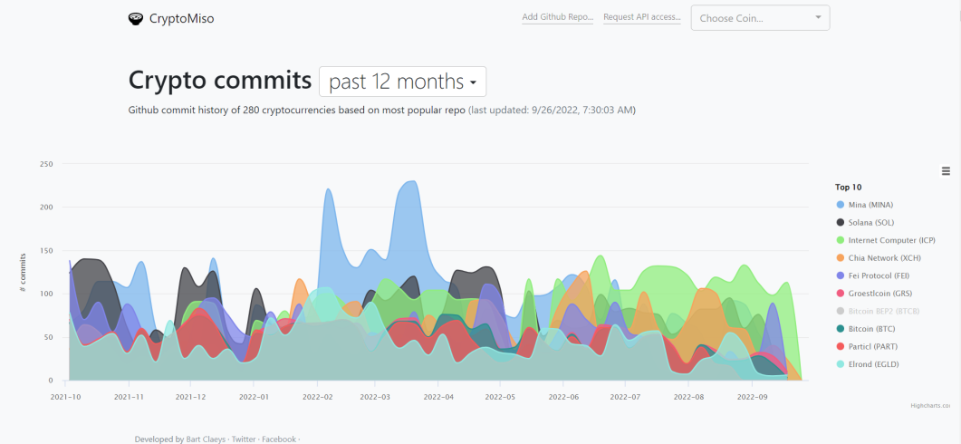

LIMITATIONS OF EXISTING SOLUTIONS:

* Graphs are too complex to understand
* New users finds it difficult to user

7

CHAPTER 3

PROPOSED SYSTEM

8

**CHAPTER 3**

**PROPOSED SYSTEM**

**3.1 PROPOSED SOLUTION**

A website where all the data about cryptocurrencies is provided. This website is made for those who have less knowledge about cryptocurrencies and for those who want know more or invest/trade in cryptocurrencies and keep track of every currency. The user is provided with a search option where he/she can search the required currency which helps in saving time to the user. In the interface the website show the currencies and show the increase/decrease percentage of that particular currency by comparing it with the previous day value. when the user clicks and enter a particular cryptocurrency they can see the detailed graph of previous day, last month ,last 3 months and last 1 year. The user can also login using Gmail or email id and bookmark the cryptocurrencies so that they can monitor the currencies whenever required. All the data of the website is stored in the firebase database in organized and is stored in real-time.

**FUTURE SCOPE:**

• Efficient use of resources through rising productivity by automation

• The application provides a report that could be used for different purposes, such as accounting management and reference for future.

• It satisfies the requirement of users.

• Understanding the working of system is not complicated in case of both the users and the admin.

• Easy to operate.

• Have a good UI

• Scalable

9

**3.2 SOURCE CODE:**

->Here are the important parts of the code.

**CURRENCY PAGE CODE:**

import axios from "axios";

import { useEffect, useState } from "react";

import { HistoricalChart } from "../config/api";

import { Line } from "react-chartjs-2";

import {

  CircularProgress,

  createTheme,

  makeStyles,

  ThemeProvider,

} from "@material-ui/core";

import SelectButton from "./SelectButton";

import { chartDays } from "../config/data";

import { CryptoState } from "../CryptoContext";

const **CoinInfo** = ({ coin }) => {

  const [historicData, setHistoricData] = **useState**();

  const [days, setDays] = **useState**(1);

  const { currency } = **CryptoState**();

  const [flag,setflag] = **useState**(false);

  const **useStyles** = **makeStyles**((theme) => ({

    container: {

      width: "75%",

      display: "flex",

      flexDirection: "column",

      alignItems: "center",

      justifyContent: "center",

      marginTop: 25,

      padding: 40,

      [theme.breakpoints.**down**("md")]: {

        width: "100%",

        marginTop: 0,

        padding: 20,

        paddingTop: 0,

      },

    },

  }));

  const classes = **useStyles**();

10

  const **fetchHistoricData** = async () => {

    const { data } = await axios.**get**(**HistoricalChart**(coin.id, days, currency));

**setflag**(true);

**setHistoricData**(data.prices);

  };

  console.**log**(coin);

**useEffect**(() => {

**fetchHistoricData**();

*// eslint-disable-next-line react-hooks/exhaustive-deps*

  }, [days]);

  const darkTheme = **createTheme**({

    palette: {

      primary: {

        main: "#fff",

      },

      type: "dark",

    },

  });

  return (

    <**ThemeProvider** *theme*={darkTheme}>

      <div *className*={classes.container}>

        {!historicData | flag===false ? (

          <**CircularProgress**

*style*={{ color: "#00FFFF" }}

*size*={250}

*thickness*={1}

          />

        ) : (

          <>

            <**Line**

*data*={{

                labels: historicData.**map**((coin) => {

                  let date = new **Date**(coin[0]);

                  let time =

                    date.**getHours**() > 12

                      ? `${date.**getHours**() - 12}:${date.**getMinutes**()} PM`

                      : `${date.**getHours**()}:${date.**getMinutes**()} AM`;

                  return days === 1 ? time : date.**toLocaleDateString**();

                }),

                datasets: [

                  {

                    data: historicData.**map**((coin) => coin[1]),

11

                    label: `Price ( Past ${days} Days ) in ${currency}`,

                    borderColor: "#00FFFF",

                  },

                ],

              }}

*options*={{

                elements: {

                  point: {

                    radius: 1,

                  },

                },

              }}

            />

            <div

*style*={{

                display: "flex",

                marginTop: 20,

                justifyContent: "space-around",

                width: "100%",

              }}

            >

              {chartDays.**map**((day) => (

                <**SelectButton**

*key*={day.value}

*onClick*={() => {**setDays**(day.value);

**setflag**(false);

                  }}

*selected*={day.value === days}

                >

                  {day.label}

                </**SelectButton**>

              ))}

            </div>

          </>

        )}

      </div>

    </**ThemeProvider**>

  );

};

export default CoinInfo;

12

**CURRENCY TABLE CODE;**

import React, { useEffect, useState } from "react";

import { makeStyles } from "@material-ui/core/styles";

import Pagination from "@material-ui/lab/Pagination";

import {

  Container,

  createTheme,

  TableCell,

  LinearProgress,

  ThemeProvider,

  Typography,

  TextField,

  TableBody,

  TableRow,

  TableHead,

  TableContainer,

  Table,

  Paper,

} from "@material-ui/core";

*// import axios from "axios";*

*// import { CoinList } from "../config/api";*

import { useHistory } from "react-router-dom";

import { CryptoState } from "../CryptoContext";

export function **numberWithCommas**(x) {

  return x.**toString**().**replace**(/\B(?=(\d{3})+(?!\d))/g, ",");

}

export default function **CoinsTable**() {

  const [search, **setSearch**] = **useState**("");

  const [page, **setPage**] = **useState**(1);

  const { currency, symbol, coins, loading, fetchCoins } = **CryptoState**();

  const **useStyles** = **makeStyles**({

    row: {

      backgroundColor: "#16171a",

      cursor: "pointer",

      "&:hover": {

        backgroundColor: "#131111",

      },

      fontFamily: "Montserrat",

    },

    pagination: {

      "& .MuiPaginationItem-root": {

13

        color: "#00FFFF",

      },

    },

  });

  const classes = **useStyles**();

  const history = **useHistory**();

  const darkTheme = **createTheme**({

    palette: {

      primary: {

        main: "#fff",

      },

      type: "dark",

    },

  });

  console.**log**(coins);

**useEffect**(() => {

**fetchCoins**();

*// eslint-disable-next-line react-hooks/exhaustive-deps*

  }, [currency]);

  const **handleSearch** = () => {

    return coins.**filter**(

      (coin) =>

        coin.name.**toLowerCase**().**includes**(search) ||

        coin.symbol.**toLowerCase**().**includes**(search)

    );

  };

  return (

    <**ThemeProvider** *theme*={darkTheme}>

      <**Container** *style*={{ textAlign: "center" }}>

        <**Typography**

*variant*="h4"

*style*={{ margin: 18, fontFamily: "Montserrat" }}

        >

          Prices of Cryptocurrency

        </**Typography**>

        <**TextField**

*label*="Search For a Cryptocurrency.."

*variant*="outlined"

*style*={{ marginBottom: 20, width: "100%" }}

*onChange*={(e) => **setSearch**(e.target.value)}

        />

14

        <**TableContainer** *component*={Paper}>

          {loading ? (

            <**LinearProgress** *style*={{ backgroundColor: "#00FFFF" }} />

          ) : (

            <**Table** *aria-label*="simple table">

              <**TableHead** *style*={{ backgroundColor: "#00FFFF" }}>

                <**TableRow**>

                  {["Coin", "Price", "24h Change", "Market Cap"].**map**((head) => (

                    <**TableCell**

*style*={{

                        color: "black",

                        fontWeight: "700",

                        fontFamily: "Montserrat",

                      }}

*key*={head}

*align*={head === "Coin" ? "" : "right"}

                    >

                      {head}

                    </**TableCell**>

                  ))}

                </**TableRow**>

              </**TableHead**>

              <**TableBody**>

                {**handleSearch**()

                  .**slice**((page - 1) * 10, (page - 1) * 10 + 10)

                  .**map**((row) => {

                    const profit = row.price_change_percentage_24h > 0;

                    return (

                      <**TableRow**

*onClick*={() => history.**push**(`/coins/${row.id}`)}

*className*={classes.row}

*key*={row.name}

                      >

                        <**TableCell**

*component*="th"

*scope*="row"

*style*={{

                            display: "flex",

                            gap: 15,

                          }}

                        >

                          <img

*src*={row?.image}

*alt*={row.name}

*height*="50"

*style*={{ marginBottom: 10 }}

                          />

15

                          <div

*style*={{ display: "flex", flexDirection: "column" }}

                          >

                            <span

*style*={{

                                textTransform: "uppercase",

                                fontSize: 22,

                              }}

                            >

                              {row.symbol}

                            </span>

                            <span *style*={{ color: "darkgrey" }}>

                              {row.name}

                            </span>

                          </div>

                        </**TableCell**>

                        <**TableCell** *align*="right">

                          {symbol}{" "}

                          {**numberWithCommas**(row.current_price.**toFixed**(2))}

                        </**TableCell**>

                        <**TableCell**

*align*="right"

*style*={{

                            color: profit > 0 ? "rgb(14, 203, 129)" : "red",

                            fontWeight: 500,

                          }}

                        >

                          {profit && "+"}

                          {row.price_change_percentage_24h.**toFixed**(2)}%

                        </**TableCell**>

                        <**TableCell** *align*="right">

                          {symbol}{" "}

                          {**numberWithCommas**(

                            row.market_cap.**toString**().**slice**(0, -6)

                          )}

                          M

                        </**TableCell**>

                      </**TableRow**>

                    );

                  })}

              </**TableBody**>

            </**Table**>

          )}

        </**TableContainer**>

        {*/* Comes from @material-ui/lab */*}

        <**Pagination**

*count*={(**handleSearch**()?.length / 10).**toFixed**(0)}

16

*style*={{

            padding: 20,

            width: "100%",

            display: "flex",

            justifyContent: "center",

          }}

*classes*={{ ul: classes.pagination }}

*onChange*={(_, value) => {

**setPage**(value);

            window.**scroll**(0, 450);

          }}

        />

      </**Container**>

    </**ThemeProvider**>

  );

}

**HEADER CODE:**

import {

  AppBar,

  Container,

  MenuItem,

  Select,

  Toolbar,

  Typography,

} from "@material-ui/core";

import {

  createTheme,

  makeStyles,

  ThemeProvider,

} from "@material-ui/core/styles";

import { useHistory } from "react-router-dom";

import { CryptoState } from "../CryptoContext";

import AuthModal from "./Authentication/AuthModal";

import UserSidebar from "./Authentication/UserSidebar";

const **useStyles** = **makeStyles**((theme) => ({

  title: {

    flex: 1,

    color: "  #00FFFF",

    fontFamily: "Montserrat",

    fontWeight: "bold",

17

    cursor: "pointer",

  },

}));

const darkTheme = **createTheme**({

  palette: {

    primary: {

      main: "#fff",

    },

    type: "dark",

  },

});

function **Header**() {

  const classes = **useStyles**();

  const { currency, setCurrency , user} = **CryptoState**();

  const history = **useHistory**();

  return (

    <**ThemeProvider** *theme*={darkTheme}>

      <**AppBar** *color*="transparent" *position*="static">

        <**Container**>

          <**Toolbar**>

            <**Typography**

*onClick*={() => history.**push**(`/`)}

*variant*="h6"

*className*={classes.title}

            >

              Cryptocurrency Analyzer

            </**Typography**>

            {*/* <Button color="inherit">Login</Button> */*}

            <**Select**

*variant*="outlined"

*labelId*="demo-simple-select-label"

*id*="demo-simple-select"

*value*={currency}

*style*={{ width: 100, height: 40, marginLeft: 15 }}

*onChange*={(e) => **setCurrency**(e.target.value)}

            >

              <**MenuItem** *value*={"USD"}>USD</**MenuItem**>

              <**MenuItem** *value*={"INR"}>INR</**MenuItem**>

            </**Select**>

             {user ? <**UserSidebar**/> : < **AuthModal** />}

          </**Toolbar**>

        </**Container**>

      </**AppBar**>

18

    </**ThemeProvider**>

  );

}

export default Header;

**CALLING API CODE:**

export const **CoinList** = (currency) =>

  `https://api.coingecko.com/api/v3/coins/markets?vs_currency=${currency}&order=market_cap_desc&per_page=100&page=1&sparkline=false`;

export const **SingleCoin** = (id) =>

  `https://api.coingecko.com/api/v3/coins/${id}`;

export const **HistoricalChart** = (id, days = 365, currency) =>

  `https://api.coingecko.com/api/v3/coins/${id}/market_chart?vs_currency=${currency}&days=${days}`;

export const **TrendingCoins** = (currency) =>

  `https://api.coingecko.com/api/v3/coins/markets?vs_currency=${currency}&order=gecko_desc&per_page=10&page=1&sparkline=false&price_change_percentage=24h`;

19

**3.3 SYSTEM REQUIRMENTS**

**HARDWARE REQUIREMENTS:**

**PROCESSOR:** DUAL CORE 2 DUOS and above

**RAM:** 2GB **HARD DISK:** 250 GB

**SOFTWARE REQUIREMENTS:**

**OPERATING SYSTEM:** WINDOWS XP/7/8/10/11, MACOS, LINUX.

**PLATFORM:** Any Web-Browser

**SCRIPTTING LANGUAGES:**

**FRONT END:** HTML, CSS, JAVASCRIPT, REACT JS.

**BACK END:** NODE JS, FIREBASE.

**API :** COIN-GECKO.

**HTML:**The Hyper Text Markup Language, or HTML is the standard mark-up language for documents designed to be displayed in a web browser. It can be assisted by technologies such as Cascading Style Sheets (CSS) and scripting languages such as JavaScript. Web browsers receive HTML documents from a web server or from local storage and render the documents into multimedia web pages. HTML describes the structure of a web page semantically and originally included cues for the appearance of the document HTML elements are the building blocks of HTML pages. With HTML constructs, images and other objects such as interactive forms may be embedded into the rendered page. HTML provides a means to create structured documents by denoting structural semantics for text such as headings, paragraphs, lists, links, quotes and other items. HTML elements are delineated by tags, written using angle brackets. Tags such as directly introduce content into the page. Other tags such as surround and provide information about document text and may include other tags as sub-elements. Browsers do not display the HTML tags, but use them to interpret the content of the page. HTML can embed programs written in a scripting language such as JavaScript, which affects the behavior and content of web pages, Inclusion of CSS defines the look and layout of content.

20

**CSS:**

Cascading Style Sheets (CSS) is a style sheet languag8e used for describing the presentation of a document written in a markup language such as HTML CSS is a cornerstone technology of the World Wide Web, alongside HTML and JavaScript, CSS is designed to enable the separation of presentation and content, including layout, colors, and fonts. This separation can improve content accessibility, provide more flexibility and control in the specification of presentation characteristics, enable multiple web pages to share formatting by specifying the relevant CSS in a separate CSS file which reduces complexity and repetition in the structural content as well as enabling the CSS file to be cached to improve the page load spend between the pages that share the file and its formatting.Separation of formatting and content also makes it feasible to present the same markup page in different styles for different rendering methods, such as on-screen, in print, by voice (via speech- based browser or screen reader), and on Braille-based tactile devices. CSS also has rules for alternate formatting if the content is accessed on a mobile device. The name cascading comes from the specified priority scheme to determine which style rule applies if more than one rule matches a particular element. This cascading priority scheme is predictable. The CSS specifications are maintained by the World Wide Web Consortium (W3C). Internet media type (MIME type) is registered for use with CSS by RFC 2318 (March 1998). The W3C operates a free CSS validation service for CSS documents. In addition to HTML, other markup languages support the use of CSS including XHTML, plain XML, SVG, and XUL.

**JAVASCRIPT:**

JavaScript (often shortened JS) is a lightweight, interpreted, object-oriented language with first class functions, and is best known as the scripting language for Web pages, but it's used in many non-browser environments as well. It is a prototype-based, multi-paradigm scripting language that is dynamic, and supports object-oriented, imperative, and functional programming styles. JavaScript runs on the client side of the web, which can be used to design /program how the web pages behave on the occurrence of an event. JavaScript is an easy to learn and also powerful scripting language, widely used for controlling web page behavior. Contrary to popular misconception, JavaScript is not "Interpreted Java". In a nutshell, JavaScript is a dynamic scripting language supporting prototype-based object construction. The basic syntax is intentionally similar to both Java and C++ to reduce the number of new concepts required to learn the language.

21

Language constructs, such as if statements, for and while loops, and switch and try catch blocks function the same as in these languages (or nearly so). JavaScript can function as both a procedural and an object oriented language. Objects are created programmatically in JavaScript, by attaching methods and properties to otherwise empty objects at run time, as opposed to the syntactic class definitions common in compiled languages like C++ and Java. Once an object has been constructed it can be used as a blueprint (or prototype) for creating similar objects.

JavaScript's dynamic capabilities include runtime object construction, variable parameter lists. function variables, dynamic script creation (via eval), object introspection (via for in), and source code recovery (JavaScript programs can decompile function bodies back into their source text.

**NODEJS:**

Nodejs is a server-side platform built on Google Chrome's JavaScript Engine (V8 Engine). Node.js was developed by Ryan Dahl in 2009 and its latest version is v0.10.36. Node.js is an open source, cross-platform runtime environment for developing server-side and networking applications.

Nodejs applications are written in JavaScript, and can be run within the Nodejs runtime on 05 X, Microsoft Windows, and Linux. Nodejs also provides a rich library of various JavaScript modules which simplifies the development of web applications using Nodejs to a great extent Nodejs Runtime Environment + JavaScript Library Following are some of the important features that make Node is the first choice of software architects.

• Asynchronous and Event Driven- All APIs of Nodejs library are asynchronous, that is, non-blocking. It essentially means a Node.js based server never waits for an API to return data. The server moves to the next API after calling it and a notification mechanism of Events of Nodejs helps the server to get a response from the previous API call.

• Very Fast-Being built on Google Chrome's V8 JavaScript Engine, Nodejs library is very fast in code execution.

• Single Threaded but Highly Scalable-Nodejs uses a single threaded model with event looping Event mechanism helps the server to respond in a non-blocking way and makes the server highly scalable as opposed to traditional servers which create limited threads to handle requests.

22

• Nodejs uses a single threaded program and the same program can provide service to a much larger number of requests than traditional servers like Apache HTTP Server.

• No Buffering-Nodejs applications never buffer any data. These applications simply output the data in chunks.

**REACT JS:**

ReactJS tutorial provides basic and advanced concepts of ReactJS. Currently, ReactJS is one of the most popular JavaScript front-end libraries which has a strong foundation and a large community.

ReactJS is a declarative, efficient, and flexible JavaScript library for building reusable UI components. It is an open-source, component-based front end library which is responsible only for the view layer of the application. It was initially developed and maintained by Facebook and later used in its products like WhatsApp & Instagram.

The main objective of ReactJS is to develop User Interfaces (UI) that improves the speed of the apps. It uses virtual DOM (JavaScript object), which improves the performance of the app. The JavaScript virtual DOM is faster than the regular DOM. We can use ReactJS on the client and server-side as well as with other frameworks. It uses component and data patterns that improve readability and helps to maintain larger apps.

23

CHAPTER 4

DESIGNING

24

**4.1Proposed System Architecture:**

The diagram shows the structure of the system(website).

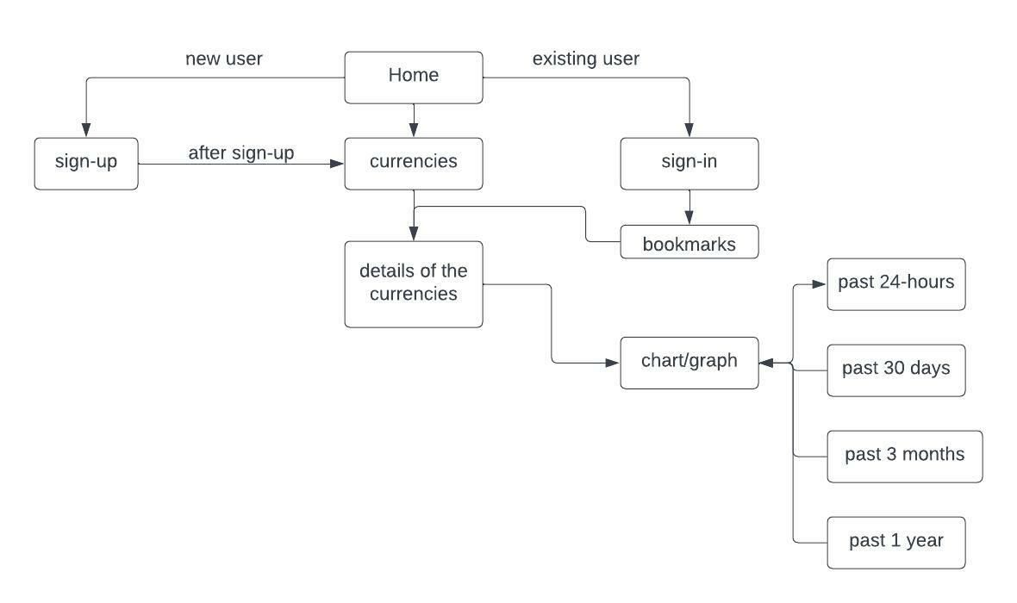

25

CHAPTER 5

RESULTS AND

DISCUSSION

26

**5.1 Results:**

HEADER:

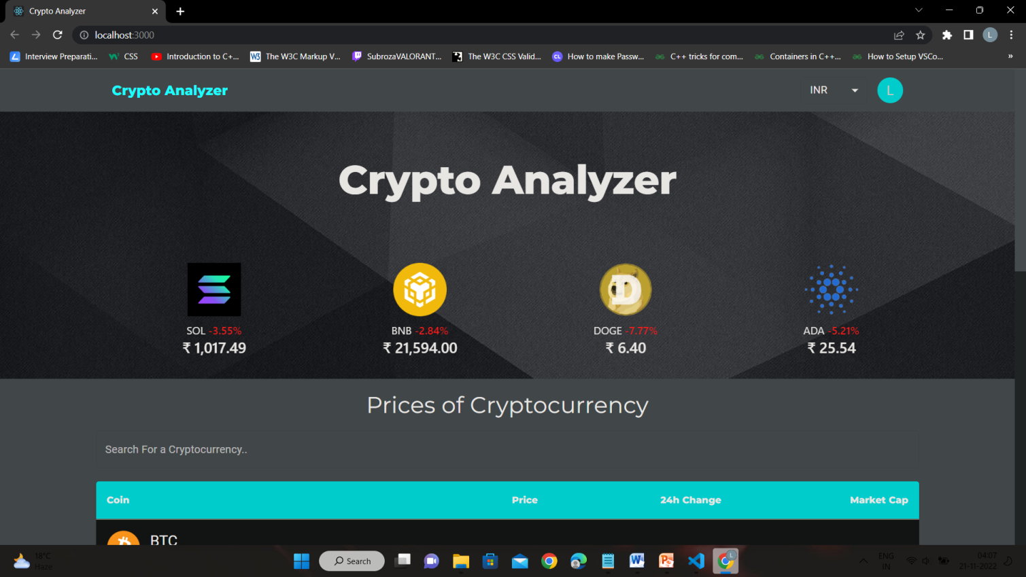

CRYPTOCURRENCIES TABLE:

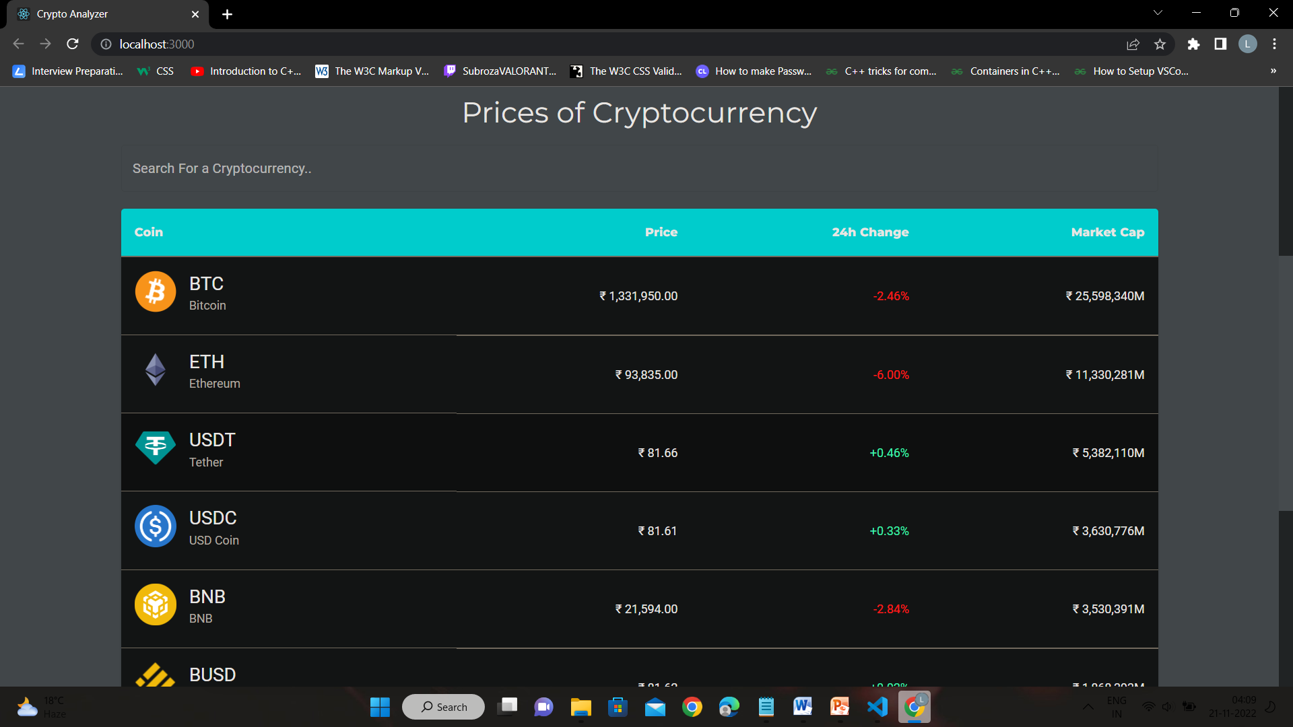

27

SIGN-UP PAGE:

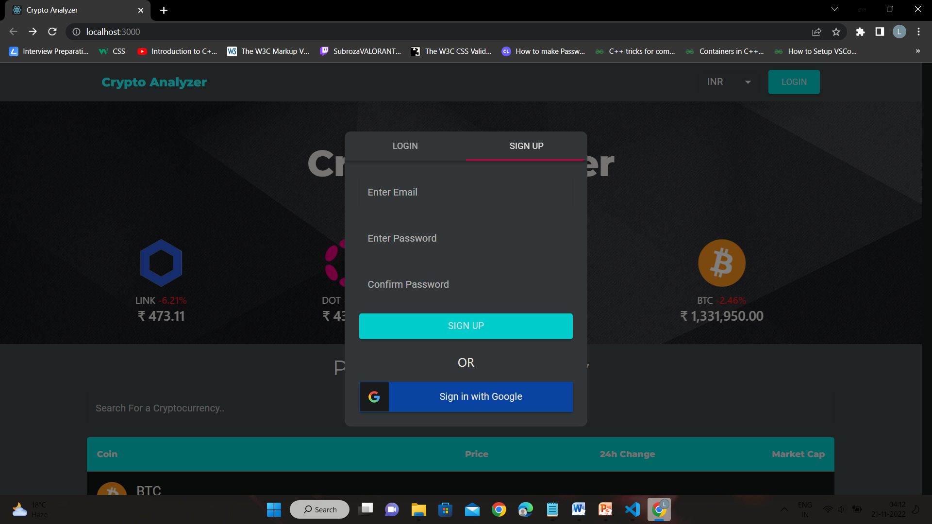

LOGIN PAGE:



28

CURRENCY PAGE:

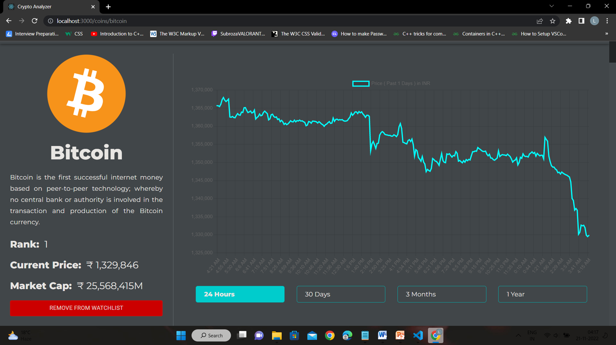

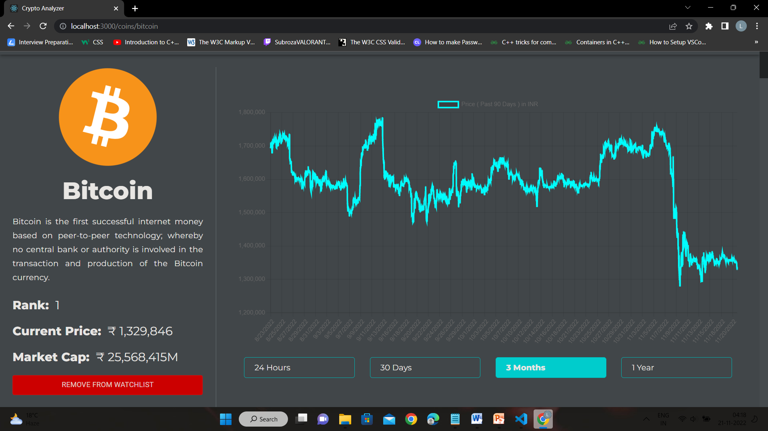

29

WATCH LIST :

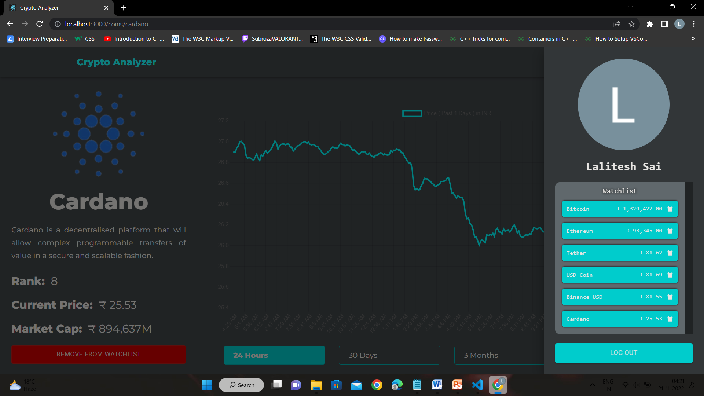

FIREBASE DATABASE:

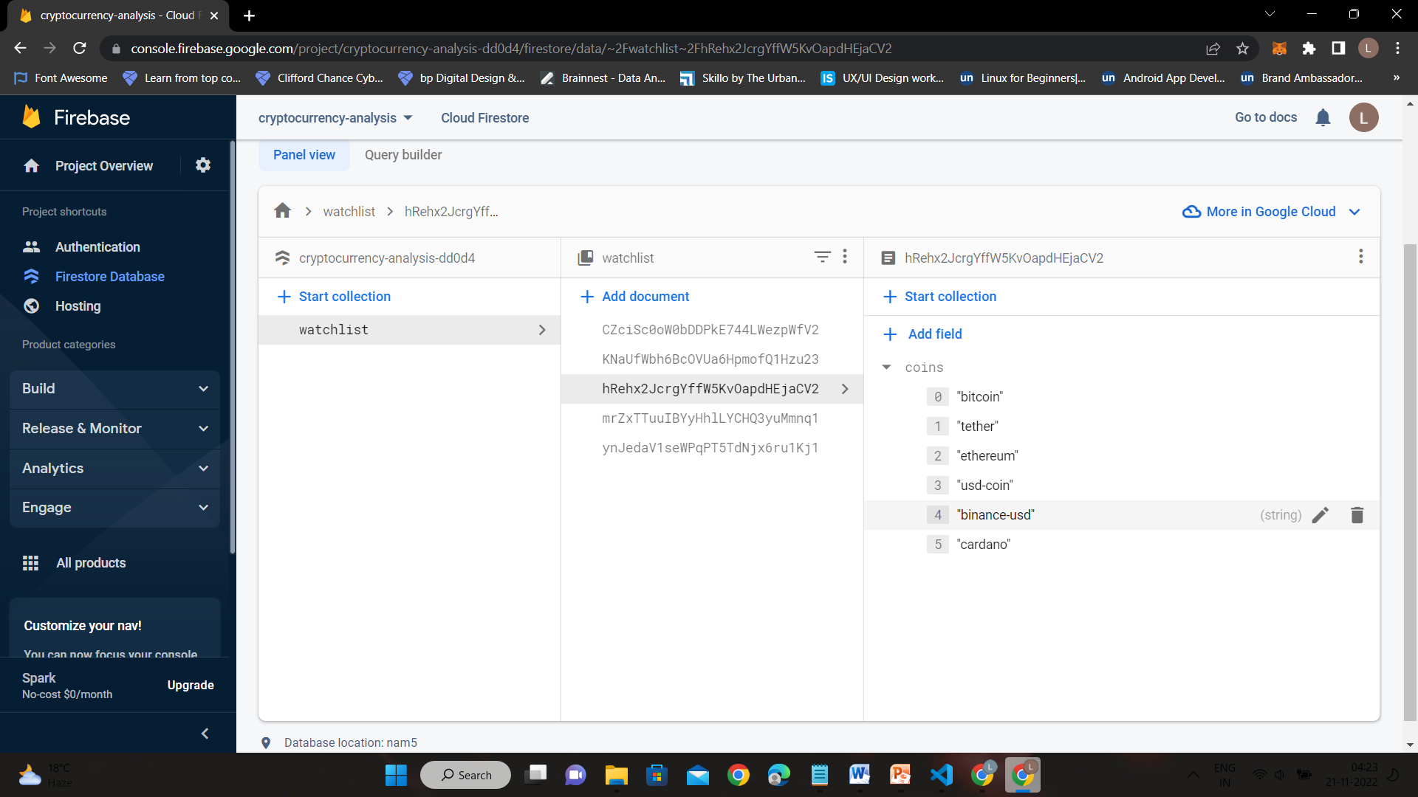

30

CHAPTER 6

CONCLUSION AND

FUTURE WORK

31

6.1 Conclusion :

A website has been made in which users can now easily know the details of cryptocurrencies , and there is no need to search each and every page for desired currency instead search option is provided. A user-friendly and simple website has been made where even a person who finds difficulties in understanding the user-interface and charts of cryptocurrencies can understand easily through our website.

6.2 Future Work :

* To add more features like live value of each currency
* The website can be developed into a mobile application
* Features like Two-factor authentication can be added
* Making the website secure

32

CHAPTER 7

REFERENCES

33

**7.1 References:**

* [**https://pdxscholar.library.pdx.edu/cgi/viewcontent.cgi?article=1219&context=etm_fac**](https://pdxscholar.library.pdx.edu/cgi/viewcontent.cgi?article=1219&context=etm_fac)
* [**https://www.researchgate.net/publication/228194929_Illusions_in_Regression_Analysis**](https://www.researchgate.net/publication/228194929_Illusions_in_Regression_Analysis)
* [**https://www.researchgate.net/publication/349502278_Cryptocurrencies_in_Modern_Finance_A_Literature_Review**](https://www.researchgate.net/publication/349502278_Cryptocurrencies_in_Modern_Finance_A_Literature_Review)

34